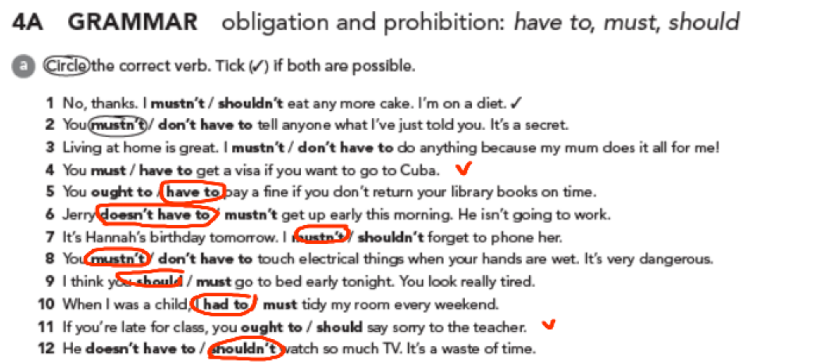

4b

2. mustn’t

3. don’t have to

4. must / have to

5. don’t have to

6. must / have to

7. mustn’t

8. have to / must

Rules:

1. Respect my home: Treat my home as you would treat your own, keeping it clean and tidy.

2. Remove your shoes: Please take off your shoes at the entrance to keep the floors clean.

3. Communicate your arrival time: Let me know in advance when you plan to arrive, so I can be prepared.

4. No smoking: My home is a smoke-free zone, so please refrain from smoking inside or near the windows.

5. Ask before bringing pets: Check with me first if you want to bring your pet along, as I may have certain restrictions.

6. Keep noise levels reasonable: Be mindful of other people living nearby, especially during late hours, by keeping noise levels down.

7. Clean up after yourself: Please tidy up after using common areas, such as the kitchen or bathroom.

8. Respect my privacy and belongings: Avoid entering restricted areas and using personal belongings without permission.

9. Inform about any damages: If accidentally something breaks or gets damaged, please let me know immediately.

10. Enjoy your visit: Above all, have a great time during your stay and feel comfortable in my home. (It seems to me that this is the most important rule)